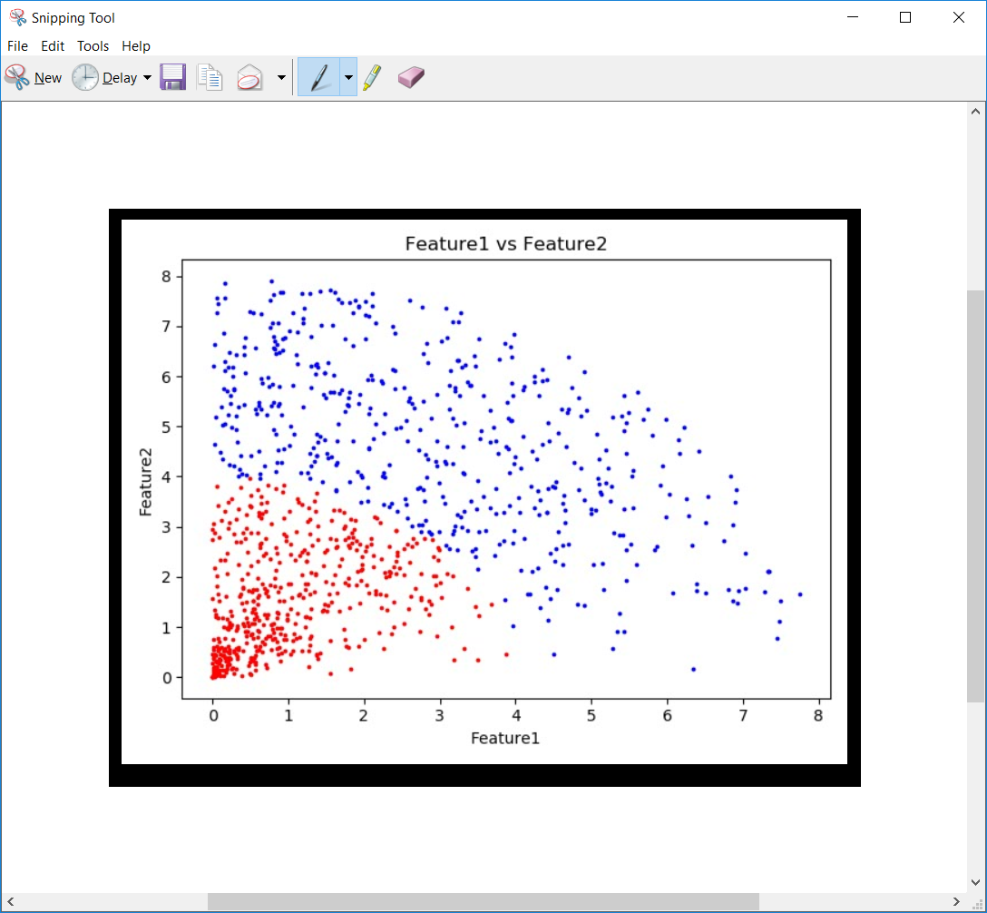

The best features :-

1. We can see a significant difference between the the regions of label 1 and label 2
2. Easily differentiated ( do not overlap)

These two features are best seen the over plot